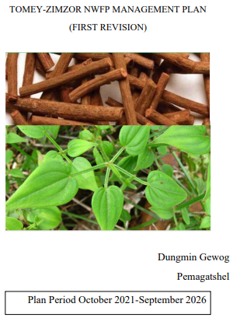

Contents
EXECUTIVE SUMMARY 5
PART 1: BACKGROUND INFORMATION 6
1.1: Rubia (Rubia cordifolia) 6
1.2 Youngjuva (Pouzolzia sanguinea) 6
1.3 Shokshokpa(Daphne bholua) 7
PART 2: NWFPS MANAGEMENT AND MARKETING PLAN 8
2.1: The objectives of the management plan are given below: 8
2.2: NWFPs descriptions 8
2.5: Marketing and sales plan 11
2.6: Marketing arrangements 11
2.7: Benefits to the members 11
2.8: Benefits to the group 12
PART 3: BY-LAWS-GROUP REGULATIONS AND NORMS 13
3.1: Members of the NWFP management & marketing group 13
3.2: Committee members 13
Responsibilities and rights of members: 13
3.2.1: Chairperson 14
3.2.2: Secretary 14
3.2.3: Treasurer 14
3.3: Compensation to the committee for marketing 15
3.4: Membership fee and purpose 15
3.5: Community development fund and utilization of fund 15
3.6: Conflict resolution 15
3.7: Penalties 16

list of figures
Figure 1 :Rubia chopped and ready for sell 6
Figure 2: Dried Bark of Pouzolzia 7
Figure 3: Daphne plant 7
Figure 4: Collection areas 9
Figure 5: collection area 10

List of tables
Table 1: Block description of individual NWFPs species 8
Table:2 Prescriptions for sustainable harvesting 10
Table 3: Marketing and sales plan of NWFPs 11

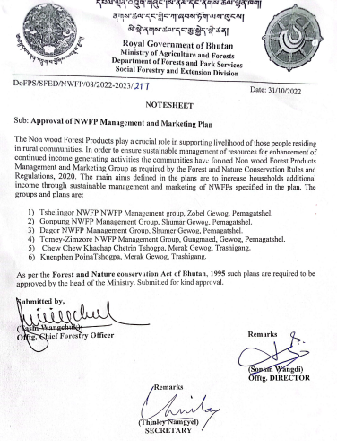

EXECUTIVE SUMMARY
Tomey-Zimzore NWFP management group was established in 2015 under guidance of Dzongkhag Forestry Sector. The initial group consists of 33 members from Tomey and Zimzore villages but five households resigned on domestic ground making it to 28 members. The group completed its five years duration without over exploiting the Non-Wood Forest Products (NWFP) available in and around their village. The group has collected and marketed Rubia cordifolia, and Pouzolzia species only. The group has been collecting NWFPs from 15 sites which fall both in SFR and Private land.
The group has potential of collecting NWFP such as Rubia cordifolia, Pouzolzia species, Neomicrocalamus andropogonifolius, Dendrocalamus spp. Daphne spp. and bamboo species and fern top. The group members also have domesticated Tupistra in their private land. Gewog forestry extension along with Dzongkhag Forestry sector had guided the collection, post-harvest treatments and marketing of NWFP produce. The group has developed guidelines and By-Laws for sustainable harvesting of produce. The By-Laws clearly state that every member must sell their produce in group, so as to fetch better price and explore better market. Till now the group has not faced any problem except, members not being able to collect due to old age and resettlements. The members have plans to collect and sell other produce as well.
The group agreed to work towards achieving their goal of income generation, poverty reduction through sale of NWFP and manage resources sustainably. The group members have unanimously framed guideline for sustainable management and developed By-Laws for proper functioning of the groups. Management Plan consists of the brief description of NWFPs, descriptions of individual species including harvesting prescriptions, sketch map of NWFPs harvesting areas and marketing sales plan. The By-Laws of the management plan contained process of executive committee formation-ToR of Chairperson, Secretary and Treasurer, compensation to the executive committee for marketing, membership fee and community development fund, conflict resolution and penalties.
The term of management plan is for five years and will be effective from 2021 to 2025. During the period, they will have right to collect mentioned NWFPs as per the harvesting guidelines prescribed in the plan and ensure sustainability of resources in the future.

PART 1: BACKGROUND INFORMATION

Following are short descriptions of species and their uses. The descriptions are totally based on plant morphology. Likewise the descriptions of uses are based on local uses and other parts of Bhutan.

1.1: Rubia (Rubia cordifolia)
Rubia is local known as Laniru. Itis a perennial climbing herb.It can grow in different height depending upon environmental factors. The evergreen leaves grow in whorls of 4-7 star like around the central stem. It climbs with tiny hooks at the leaves and stem. The flower usually appears from June to August. It grows along the disturbed forest land such as forest edge and clearings and it is sparsely found in grassland and open rock outcrops. It is said to be found even at the elevation up to 2600 masl.
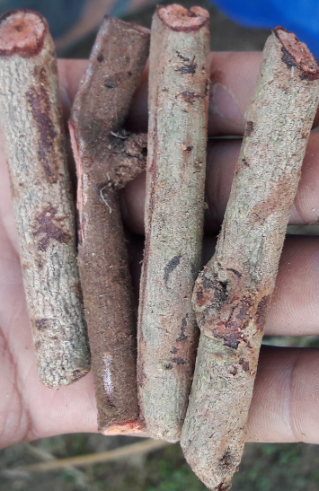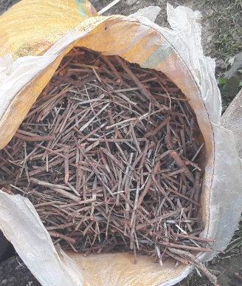
  - Figure 1 :Rubia chopped and ready for sell

Uses
Rubia is used for extraction of red pigment which is then used for dying purposes. Locally it is also used for local healing where tender leaves are crushed and used for healing body pain.

1.2 Youngjuva (Pouzolzia sanguinea)
It is an evergreen shrubs growing in warm broad leaved forests, thickets and edge of woods, dry valleys, roadside and in the patches of abandoned cultivation at elevations of 300-2300 masl.
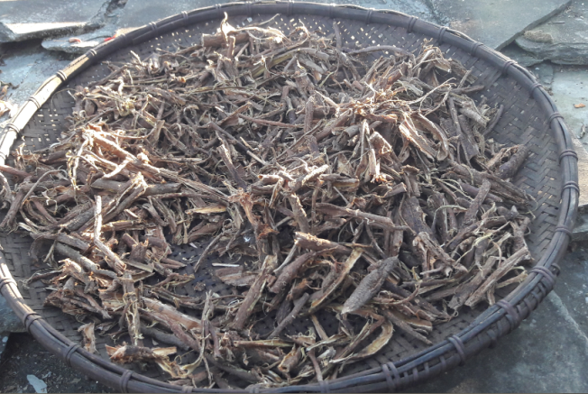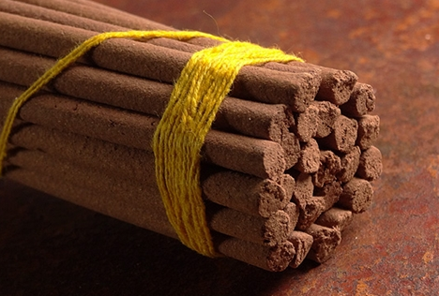
  - Figure 2: Dried Bark of Pouzolzia
Uses
It is popularly used as an important raw-material in incense manufacturing process as an adhesive to bind ingredients.

1.3 Shokshokpa(Daphne bholua)
It is a species of flowering shrub; and it has leathery leaves and deep pink flowers with a powerful fragrance. The whole plant is said to be poisonous.
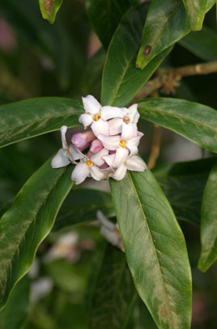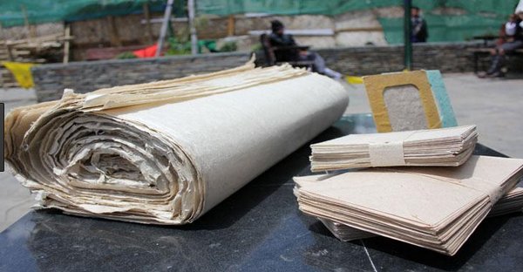
  - Figure 3: Daphne plant

Uses
D. bholua is used in traditional paper-making in Bhutan and in Nepal. People also use the inner bark to yields a fiber that is used to make rope.

PART 2: NWFPS MANAGEMENT AND MARKETING PLAN

2.1: The objectives of the management plan are given below:
- To enhance income generation to the community through sale of NWFPs.
- To manage the NWFPs resources at local level through community participations.

2.2: NWFPs descriptions

Table 1: Block description of individual NWFPs species
NWFP name | Collection area (name) | Estimated areas (acres) | Parts harvested | Use purpose (traditional and others) | Harvesting season (months) | Estimated quantity that can be collected (Kg)
Laniru (Rubiacordifolia) | Richphotkpa | 30 | Entire plants | Dye, medicine | November-February | 4500 kg
 | Tokaborang | 40
 | Dungtsho | 35
 | Dangtsiri | 10
 | Gakpuri | 10
 | Seri | 10
 | Omshari | 10
 | Pangthangchilo | 10
 | Lebiri | 10
 | Grompakhoi | 10
 | Dingshingzor | 10
 | Dangramanma | 10
Youngjuba (Pouzolzia sanguine | Richphotkpa | 30 | Bark | Adhesive for incense | August-February | 3000 kg
 | Tokaborang | 40
 | Dungtsho | 35
 | Dangtsiri | 10
 | Gakpuri | 10
 | Seri | 10
 | Omshari | 10
 | Pangthangchilo | 10
 | Lebiri | 10
 | Grompakhoi | 10
 | Dingshingzor | 10
 | Dangramanma | 10

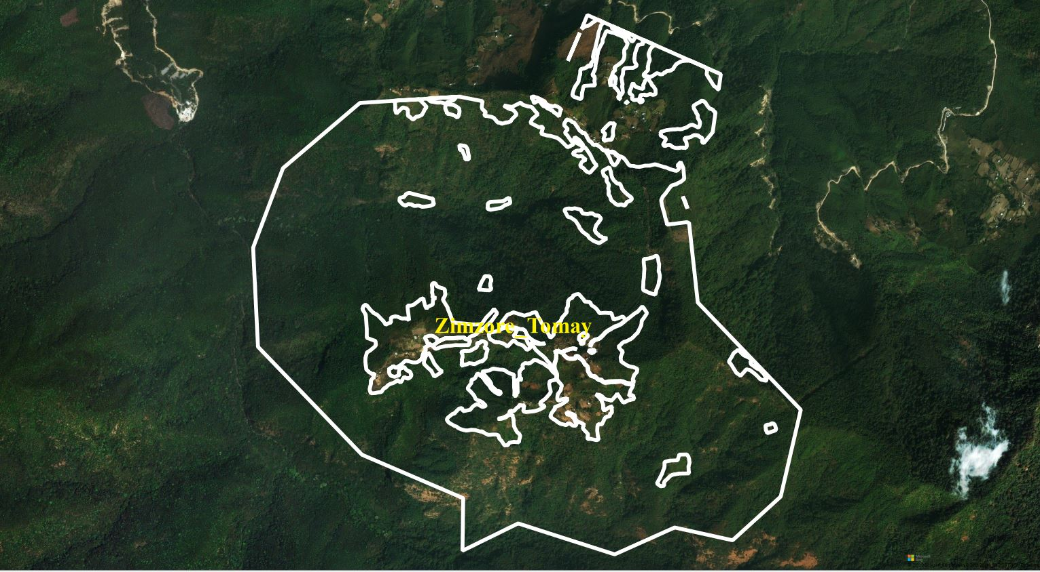
  - Figure 4: Collection areas
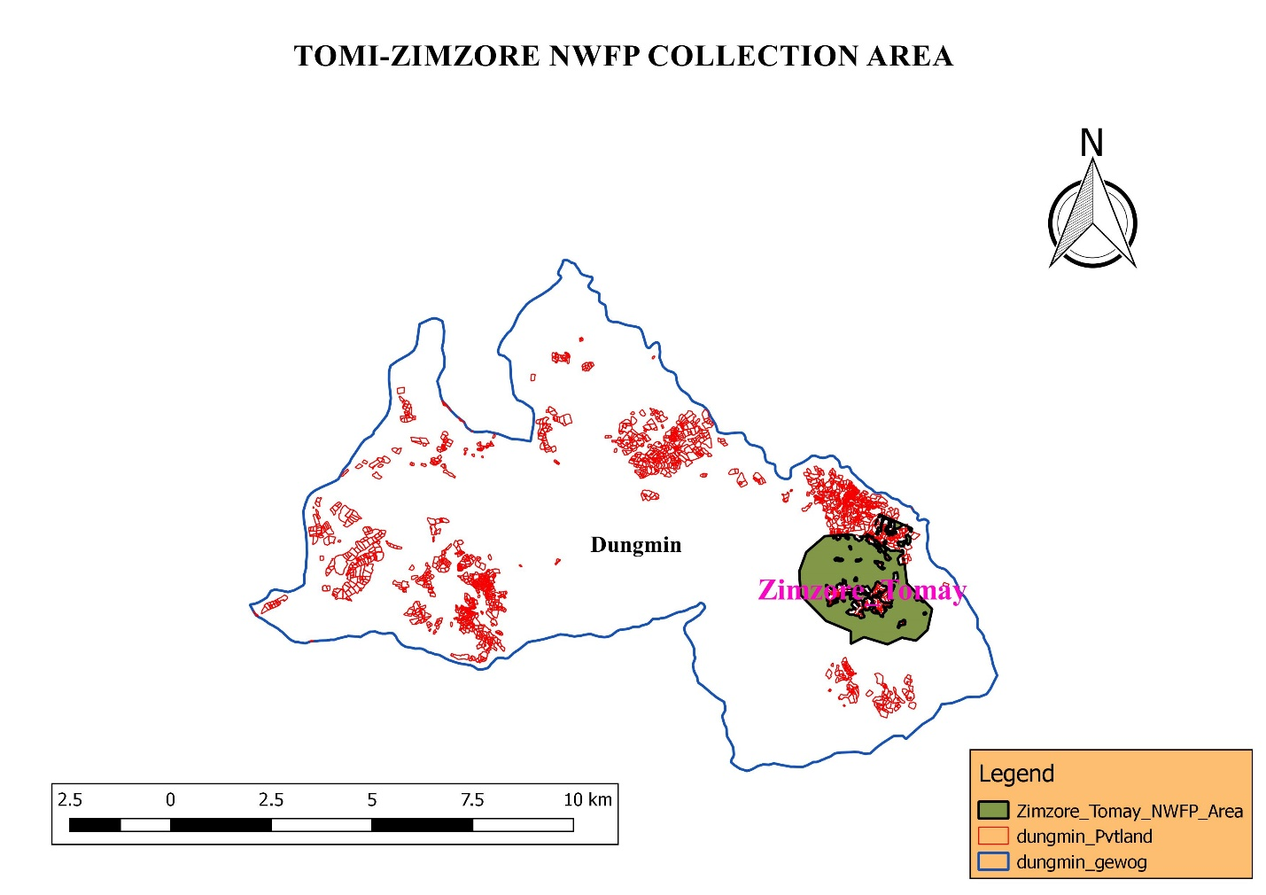
  - Figure 5: collection area

Table:2 Prescriptions for sustainable harvesting
NWFP species | Harvesting prescriptions for sustainable harvesting
Laniroo(Rubiacordifolia) | -Use sharp scissors for the collection of the upper part of the plant.  -Cut the plant at 5 cm above ground level.  -Leave at least 10% of the plants without collecting or harvesting any raw materials from them (these plants shall act as seed plants for natural regeneration).  -Do not collect roots.  -Do not uproot entire plants  -Leave the mother plant intact with small part of the root or rhizome in the soil (this left part of rhizome will regenerate in the following year).  -Harvest rhizomes only during the collection season.
Youngjuva(Pouzolzia sanguine) | -Cut the plant at 10 cm above the ground level (the left stump will coppice in the following growing season).  -Do not damage the remaining young stands/ seedlings/ saplings  -Felling of surrounding trees to ease harvesting is prohibited.  -Leave at least 10% of the plants to allow natural regeneration.  -Collection of roots is strictly prohibited for ecological reasons

2.5: Marketing and sales plan

Table 1: Marketing and sales plan of NWFPs
NWFP name | Potential market | Estimated quantity for sale per season | Expected price per unit | Total Nu.
Laniru (Rubiacordifolia) | Local trader, Indian market | 900kgs. | 70.00 | 63000.00
Yongjiba (Pouzolzia sanguine | Local trader, poi making factory and Indian market | 600kgs | 35.00 | 21000.00

2.6: Marketing arrangements

The members will collect the NWFPs individually and store properly at their home. The members will segregate products as per the standards required by the trader. The committee members will inform individual members to bring the NWFPs product to the auction yard or identified selling place and inform to the concern forestry official/DAMC. The concern forestry official/DAMC will then organize NWFPs auction with various NWFPs traders. As of now there is no record of involvement of officials from DAMC and as such no auction has been conducted. Still then, members have agreed to organize auction in the presence of Chairperson from the respective NWFPs groups as a representative on behalf of the group.
The committe members may deduct the expenditure such as transportation, community fund and compensation before making payment to the group. The sharing of income to the individual group member will be done based on the quantity of NWPs collected by the respective members after deduction of all necessary expenditure.

2.7: Benefits to the members
The members switched to NWFP as the mandarin oranges production declined over the years. NWFPs resources from their vicinity forest plays significant roles in income generation. In the last plan period, the income generation among members ranged between Nu: 2000-10000 based on quantity collected by individuals. The income from sale of NWFP enabled members to meet their basic necessities like buying of salt, rice, sugar, etc. Furthermore, the income also helps in buying of clothes, shoes, books and pens for their school children.

2.8: Benefits to the group
By forming this group, all the individual members have equal opportunities to access the resources. The group will be able to collect the various NWFP products legally which otherwise the individual members cannot get any valid permit to collect these NWFPs. Moreover, the group can also save the community fund which they can use for sanctioning of members loan at low rate or they can be used for any livelihood support activities in the group.

PART 3: BY-LAWS-GROUP REGULATIONS AND NORMS

3.1: Members of the NWFP management & marketing group

3.2: Committee members
Name | Designation | Phone number | Remarks
Sonam Jamtsho | Chairperson | 17737317
Ugyen Thinley | Secretary | 77821503
Ugyen Norbu | Treasurer | 17877809

Responsibilities and rights of members:
- The group members participating in this management of NWFP will have equal rights and responsibilities for controlling, protection, management and harvesting in the identified collection areas.
- The individual members are not allowed to collect and harvest at their own will until the committee members seek permission and fixed the date.
- Every member of the group is entrusted to report to the committee members for violation of the management rules.
- The members should abide by By-Laws of group and only sale products through the group and not individually.
- Withdrawal of any group members without genuine reason is allowed without benefit from the accumulated fund and the entry fee. Withdrawn members will not be allowed to re-join the group.
- Any members who withdraw from the group member due to marriage or resettlements or other reasons will be allowed upon depositing fine of Nu. 1500/- but will not get his share from the accumulated fund.
- Resign from the group owing to old age or no children to carry out work will get his share of accumulated fund till the date of his/her resignation.

3.2.1: Chairperson
Responsibilities of Coordinator/ Chairperson:
- To chair all kinds of meeting relating to NWFPs management matter in the group.
- To resolves the disputes and conflict among the members.
- To enforce the fine and penalty.
- To explore market for the products
- Fix date of collection and make an announcement to the group member
- Maintain contacts with traders, to arrange & coordinate marketing of NWFPs and record data, etc.

3.2.2: Secretary
Responsibilities of Secretary:
- Provide assistance to the Chairperson.
- Officiate Chairperson during his absence.
- Maintain records of the activities implemented, and also minutes of meeting.
- Write official correspondence.
- Compile the progress report and submitted to the GEFO for further submission to the Divisional Forest annually.

3.2.3: Treasurer
Responsibilities of Treasurer:
- To maintain the financial matters and present the details funds to Committee and the group members.
- Officiate the Chairperson or Secretary in their absence.
- Maintain the cash transaction record, submit expenditure and cash balance report to Chairperson and present it to the group in meetings.
- Collection of membership fee from the group members.
- Taking care of financial arrangements in the group

3.3: Compensation to the committee for marketing
- The committee will work without compensation for the group for the tenure of another next five years and they will not resign in between tenure except astounding circumstances.

3.4: Membership fee and purpose
- Membership fee for the existing group should pay Nu. 100/- annually.
- Any new members wishing to join the group maybe allowed to join the group only after payment of compensation equivalent to amount each individual (old) members contributed from date of inception of group.
- The collected fee will be deposited in the joint account as a Community Development Fund (CDF) that will be used for pre-financing marketing purposes and others.

3.5: Community development fund and utilization of fund
- The bank account will be operated by Chairperson, Secretary and Treasurer, and they are signatory authority of the Bank Account. All sale and expenses done by the Chairperson, Secretary and Treasurer should be in the notice of members.
- All expenditure incurred on behalf of the group will be beard from the Joint Account. Technical support will be sought from the concerned gewog ROs.
- The source of fund will be from fine imposition, membership fees and the selling of NWFP
- The group members will deposit Nu.250 if he or she has collected less than or equal to 20 kg. And whoever has collected more than 20 kg will have to pay 10% of their earning from selling produce to the group.
- The fund accumulation will be shared among the group members to certain percentage of the total accumulation once the bank account become enough to rotate

3.6: Conflict resolution

- In case disputes or conflicts among communities arise about access to certain areas for NWFP harvesting; the matter shall be put to the Gewog Tshogchung (GT) and Dzongkhag Tshogdue (DT) for further decision.
- In case there is a conflict between the NWFP Group and outsiders, the case shall be forwarded to the Divisional Forest and Gewog Administration by the Coordinator.
- The conflict arising among the group members regarding NWFP matters will resort firstly to the Chairperson.
- If the nature of the conflict is unable to resolve by the Chairperson, the case will be forwarded to the Gewog RO for further settlement.
- Still if the conflict remains unresolved the case will be forwarded to the Gewog Administration.
- If the Gewog Administration cannot resolved the problems, the case will be forwarded to the Divisional Forest Office for further action

3.7: Penalties
- In case if the member of the NWFP Group violates the harvesting rules/prescriptions as set in this plan, he or she will not be allowed to harvest the NWFP for the rest of the season and the next season.
- Members collecting the NWFP prior to the fixed date/announcement made by the Coordinator/ RO, the product will be seized by the group
- Number of days for the collection will depend on availability of resources and general consensus by the members.
- Those members who could not collect it owing to old age or death or other genuine reasons will be considered.
- Only one member from each household will be entertained and the quantity collected by additional will be surrendered to the group.
- Non-members without registering will be not allowed to collect and the product collected will be seized by the group.
- An absentee during meeting is liable to pay Nu. 215/- per head.
- An absentee owing to death, sick or other genuine reasons are considered only after the approval from Chairperson.

Membership list
